Mage-Grow
Tre Hamilton

An aspiring Mage that has only ever been a cleaner, keeps getting her room trashed. The mysterious invader is trying to extinguish the life in her room. She needs to fix her room and continue helping her plants grow. Compete with other candidate players to win REAL CASH PRIZE!!!

Table of Contents
1. Terms 4
2. Game Attributes 4
3. Overview 4
4. Story 4
a. Setting 4
b. Story 4
c. Player Character(s) 5
d. Major Characters 5
5. Gameplay 5
a. Player objective 5
b. Areas/Zones 5
c. Major Mechanics 5
6. Artstyle 5
a. Style guideline 5
b. Mood Board 5
c. Example artwork 5
7. Music 5
a. Ambient Music 5
b. Boss Themes 5
8. UI 5
a. HUD 5
b. Menus 5
9. Technical Elements 6
a. Game Engine 6
b. Coding Languages 6
10. Team 6

Terms
Some bread would be appreciated. Maybe just a longer spring break.

Game Attributes
Genre | 3D puzzle
Genre-Adjacent Tags | Fantasy, Magic
Gamemodes | Single player, level based
Theme | Fantasy
Dimension | 3D
Perspective | 3rd person
Unique Selling Point | CASTING SPELLS
ESRB Rating | Everyone
Target Audience | Casual Gamers
Platforms | PC
Inspirations

Overview

Story

Setting
The trashed room of the character Jolleen. Normally a cozy abode, however, forces unseen have begun ruining her aesthetic.

Story
Jolleen has spent the past couple years of her life learning spells. However, due to her humble upbringings, the only class she unlocked from a young age was the cleaner class. Can she use this class and her simple spells to thwart the plans of those trying to upend her lifestyle.

Player Character
Jolleen
Half elf, half Ent. Humble Upbringings (peasant). The farthest thing from a prodigy but finds joy in the simple things like gardening.

Major Characters
????
An individual, who for some reason is trying to destroy the plant life in Jolleen’s cottage. Has a vengeance for the plants she is growing, however, directly interfering with the plants is impossible, so other means are being used to upend those darn plant’s growth.

Gameplay

Player objective
Thwart the unseen individuals trying to keep Jolleen’s plants from prospering.

Areas/Zones
Player’s home. Different nights lead to different messes in her house.

Major Mechanics
Active spell casting. Object removal and restoration.

Artstyle

Style guideline
A fantastical world filled with magic and miscreants who bother the people in it. Going for a 3D cartoony vibe of a world that is untouched by industrialization.

Mood Board
Wooden furniture and torch lit rooms. Stone walls touched by moss and lichen, aged but not ruined.

Example artwork
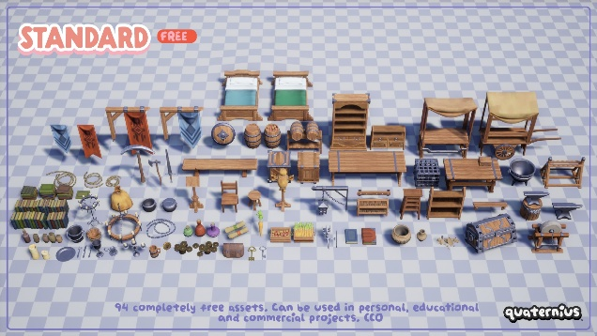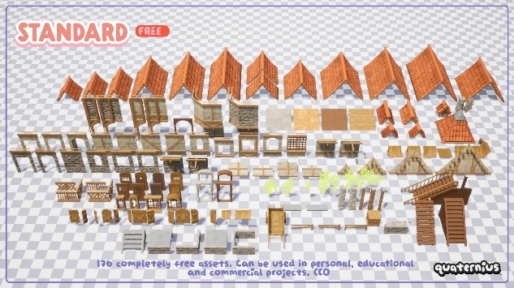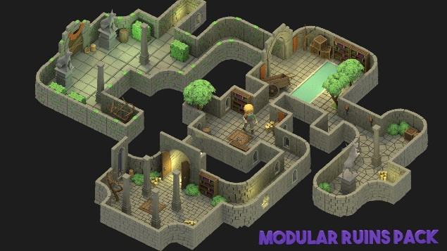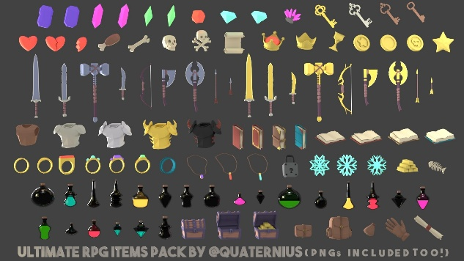

Music

Style Guideline
Medieval Tavern Ambiance. For a fantasy game in a cottage, the medieval theme is necessary. A few examples are below:

Ambient Music
Golden Brown Queen – Celestial Aeon Project (main menu)
Aerie’s Romance (Balder’s Gate 2) – Celestial Aeon Project (game)
SFX
Restore SFX - Sound Effects by DRAGON-STUDIO from Pixabay
Destroy SFX – Sound Effects by DRAGON-STUDIO from Pixabay

Boss Themes
No boss fight yet.

UI

HUD
A sprite displaying which spell the player has selected

Menus
Pause
Pause menu to stop either go back to main menu or look at the Spell book.
Spell Book
A menu displaying the use and functions of the spells Jolleen knows

Main Menu
Options include Level Select, settings, and exit to desktop.

Technical Elements

Game Engine
Unity 6 engine

Programming Languages, Libraries, and Frameworks
Language - C#
Other technical things that I don’t know yet. :/

Credits
Project director: Tre Hamilton, himself
Art Assignment: Tre Hamilton
Assets from Quaternius
Links here…
Programming Overseer: Tre Hamilton, the man, the myth??, the tired.
Music
Golden Brown Queen – Celestial Aeon Project (main menu)
Aerie’s Romance (Balder’s Gate 2) – Celestial Aeon Project (game)
SFX
Restore SFX - Sound Effects by DRAGON-STUDIO from Pixabay
Destroy SFX – Sound Effects by DRAGON-STUDIO from Pixabay

